Press Release
May 8, 2024, for immediate release

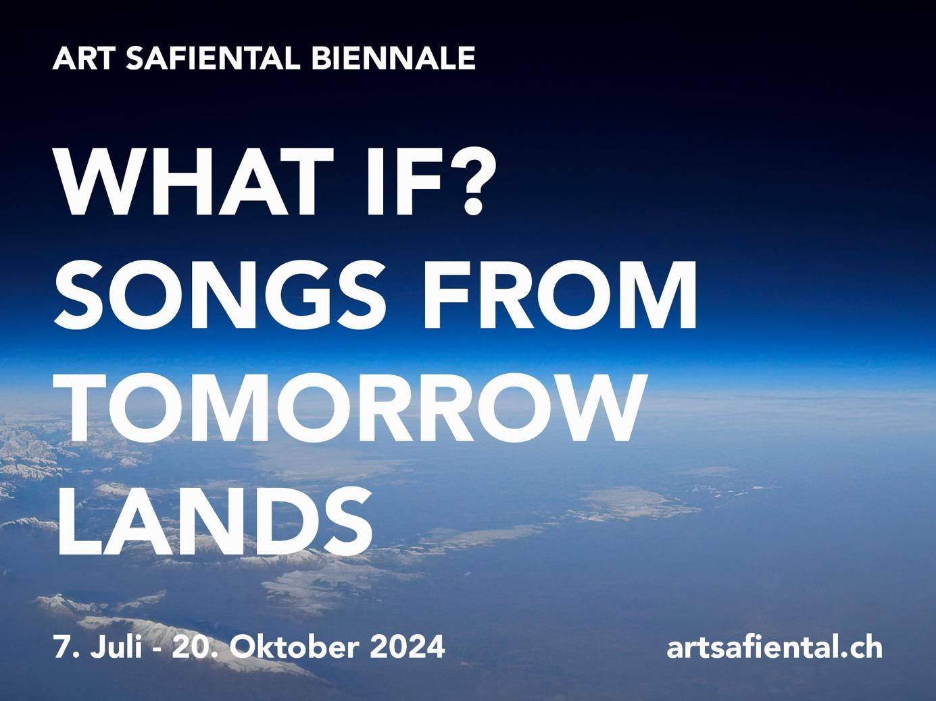

The Art Summer 2024 in Safiental CH

- 5th Art Safiental Biennale
«What if? Songs from Tomorrowlands»
July 6 to October 20, 2024 in the mountain villages of Versam, Tenna, Safien and Thalkirch
Opening: July 6/7; Performances: July 20 + September 15; Finissage: October 20, 2024
- Alps Art Academy – Symposium
«What if? Transformation in art, architecture und ecology»
August 30 to September 2, 2024 in Tenna, Lumbrein, Flims + online
- Research Exhibition «What if? – Questions to the Future»
June 1 – October 20, 2024 in the ILEA Gallery in the Berghotel Alpenblick, Tenna
- ILEA Book 2 «What if? Letters to the Future»
will be published in September 2024 by Vexer Verlag St.Gallen/Berlin



The Art Safiental Biennale reflects on our future

From July 6 to October 20, 2024, the fifth edition of the Art Safiental Biennale (since 2016) invites visitors to explore and experience contemporary land and environmental art. The topic for 2024 is: "What if? Songs from Tomorrowlands".
13 new productions by artists from Switzerland and around the world take a critical look at possible futures and our world in transition. The open-air exhibition covers the entire municipality of Safiental with a focus on the four mountain villages of Versam, Tenna, Safien Platz and Thalkirch. The Biennale is organized by the Institute for Land and Environmental Art (ILEA) under the sponsorship of the Beverin Nature Park and the municipality of Safiental, in cooperation with Safiental Tourism.
"What if?" is more than just a rhetorical question. It can inspire us to actively shape the future instead of just reacting to it. It invites us to think of possible scenarios and futures and to find ways to build a future-proof and sustainable world. Art can also break up thought patterns, offer inspiration, insight and a space for dialog and change.
For the first time, four curators are responsible for this year's Biennale: in addition to the founder, Johannes M. Hedinger, these are Anne-Laure Franchette, Josiane Imhasly and Joanna Lesnierowska. They bring fresh impulses, different perspectives and new artistic positions to the Safiental. They write in their curatorial statement:
“What if” is thus understood as world-making, driven by the idea that hope is a muscle (Björk) that must constantly be exercised. Together, we set out to reflect on and act upon the present through the lens of the times to come – by asking ourselves in the future perfect tense (Harald Welzer): What will we have done, and what will we have left undone? How do we want to be remembered, and how can we become “a good ancestor” (Roman Krznaric)?
[The full text can be found here].
General information and visit
The 13 art works (11 installations and 2 one-off performances) are spread across the Safiental, with a focus on Versam, Tenna, Safien Platz and Thalkirch. The installations can be visited free of charge during the day. Most of the locations can be reached by public transport. The Berghotel Alpenblick in Tenna serves as the information center for the exhibition. A research exhibition (What if? Questions to the future) organized by ILEA (Institute for Land and Environmental Art) will also be shown there. An exhibition guide with a map will be published for the Biennale, showing the exact locations of the artworks and providing interesting facts about the exhibition, the individual works and the Safiental. In the second half of the exhibition, an accompanying catalog (ILEA Book 2) will be published by Vexer Verlag St. Gallen/Berlin. Guided tours will be offered. The dates will be available on the website from June. Information boards on site support the mediation, as does the information on the website. Documentation of the unique performances will also be available here: www.artsafiental.ch

The projects and artists
Versam:
In early summer, the British-Japanese multimedia artist Huhtamaki Wab set off on foot from his home in southern England to the Safiental. In the Kunstgarage Versam he is showing his collected impressions as an overall installation. He is contributing a performance to the vernissage.
The Swiss artist duo Christina Hemauer and Roman Keller focus on the fact that practically all of the altitude indications on signposts in Switzerland are too low. This is partly because the Alps are growing faster than they are being eroded, and partly because the sea level is constantly rising due to global warming. In collaboration with Swisstopo and the Astronomical Institute of the University of Bern, they are developing a measuring system that now shows the altitude to the nearest centimeter at four locations in the Safiental.
Tenna:
At the Berghotel Alpenblick, we find the relational art practice of Mexican artist Paloma Ayala, who develops an oven, various objects and events based on food stories and encounters with locals from Tenna. In her video "Transient Traveller", artist Monica Ursina Jaeger, who specializes in climate issues, focuses on spruce forests and what they can teach us about time, transformation, adaptation and resilience. At the waterfall, the Brazilian artist Ernesto Neto celebrates a ritual burial of one of his works with music and dance at the beginning of the Biennale. He thematizes the fact that everything we produce and consume comes from the earth and now finds its place in the soil of the valley forever. On the Tenner Chrüz you will encounter the sculpture by the Brazilian performance duo Quarto. In a barn on the way back to the village you will find the video documentation of the performance from the day of the opening.
Safien Platz:
The works in Safien Platz all relate to the local power station, hydropower and water in general. Dutch artist Vibeke Mascini has been collaborating with the hydroelectric power plant since 2018, presenting a new video work in its side tunnels. In her feminist sound piece, Magali Dougoud, who is from the French part of Switzerland, tells the story of water creatures who rebel against established power relations, thereby denouncing the exploitation of water resources. The sound station is powered by a turbine attached to the residual water. A live performance of the piece can be experienced on site on July 20. On the same day, a one-time dance performance by Polish choreographer Ola Maciejewska will also take place in the turbine hall of the Zervreila power plant. The dancer interacts with an ice sculpture in the shape of a human shoulder blade. The melting object reflects the disappearance of the glaciers.
Thalkirch:
The contribution by Indian artist Ravi Agarwal and Chilean glaciologist Paulina Lopez deals with the cultural history of glaciers, of which a small remnant still exists in the Safien Valley. Their video essay attempts to decolonize the history of ice and glaciers and is supplemented by a collection of research and material. In the Bawald forest, visitors encounter felt vessels hanging from trees by Valais artist Stefanie Salzmann. These are intended to metaphorically collect visitors' dreams and visions of the future and encourage them to reflect on consumer behavior and the use of natural resources. The curved building profiles by the young Graubünden artist Andrea Todisco make visitors wonder whether a building of this unusual shape will really be built here. A speculative mind game: What if?
Valendas:
The performance "Under my Gaze" by Australian choreographer Renae Shadler will be shown once in the Naturarena Altaun as part of the Valendas village festival on September 15. Afterwards, the audience will be able to interact with the "Aeroscene" floating sculptures controlled by solar energy in a workshop.
Art residency:
This summer, the Berghotel Alpenblick will once again be welcoming two artists in residence funded by the Swiss Arts Council Pro Helvetia. These are the two Indian artists Farah Mulla and Sujit Mallik, who will each spend a month researching in Tenna and will also respond to the exhibition theme in a form to be determined.
Long-term projects:
The oral history project "Safientaler Gespräche" by Dominik Landwehr, which has been running since 2019, is available online and visible at the Berghotel Alpenblick. https://talks.ilea.art/
Marcus Maeder's eco-acoustic project ACLA, which has been running since 2021, has been expanded and the observatory in the Aclatobel can also be visited this summer. https://aclasoundscape.ch
Participants

Curators Art Safiental Biennale 2024
- Anne-Laure Franchette
- Johannes M. Hedinger
- Josiane Imhasly
- Joanna Lesnierowska

Artits Art Safiental Biennale 2024
- Ravi Agarwal & Paulina Lopez (IN, CL)
- Paloma Ayala (MX/CH)
- Magali Dougoud (CH)
- Hemauer/Keller (CH)
- Monica Ursina Jaeger (CH)
- Vibeke Mascini (NL)
- Ernesto Neto (BR)
- Ola Maciejewska (PL)
- Quarto (BR/SE)
- Stefanie Salzmann (CH)
- Renae Shadler & Team (AUS/DE)
- Andrea Francesco Todisco (CH)
- Huhtamaki Wab (JP/UK)

Artist Residency
- Farah Mulla (IN)
- Sujit Mallik (IN)

Dates 2024
Fri 5.7. Tenna: 10-12 am, press tour, Talk with curators and artists
Fri 5.7. Versam: evening performance by Huhtamaki Wab
Sat 6.7. Opening Art Safiental, artists’ meeting (whole valley)
Tenna: event Paloma Ayala, performance Quarto, event Ernesto Neto
Sun 7.7. Opening Art Safiental, artists’ meeting (whole valley)
Tenna: performance Ernesto Neto
Sat 20.7. Safien Platz: performances Ola Maciejewska + team
Safien Platz: performances Magali Dougoud + team
30.8. – 2.9. Alps Art Academy – Symposium (Program online from June)
Sun 15.9. Valendas: performance Renae Shadler + Team (on the occasion of the village festival)
Sun 20.10. Finissage Art Safiental (program online from 1 October)

Further Information
www.artsafiental.ch: exhibition, art projects, artists, map, events, photos, videos
www.alpsartacademy.ch: Symposium
www.ilea.art: Office, research, publications, projects, indoor exhibitions
Instagram: @land_and_environmental_art
Facebook: @alpsartacademy
Youtube: @instituteforlandandenvironment Hashtags: #artsafiental, #whatif, #ilea

Press photos
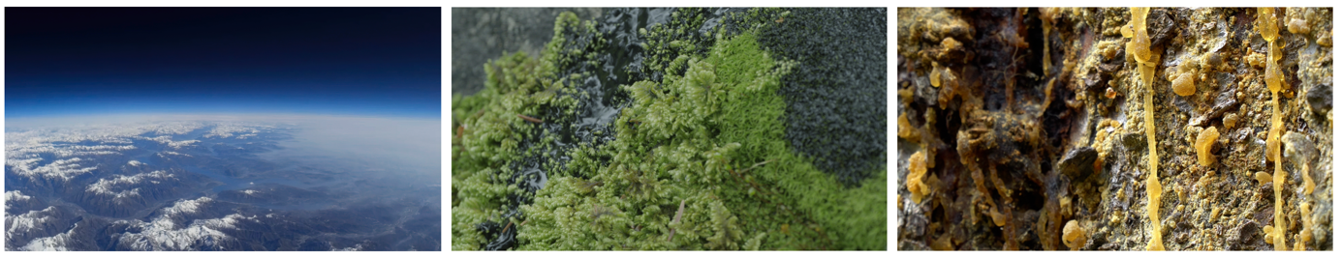
1: Hemauer/Keller: Solarballonflug (2016); 2+3: Monica Ursina Jaeger: Transient Traveller (2023); to download here

Contact and information for the media
Susi Schildknecht, media representative: susi.schildknecht@bluewin.ch, Tel. +41 79 605 32 84
Johannes M. Hedinger, founder/artistic director: hedinger@ilea.art
Benedikt Joos, project manager Naturpark Beverin: benedikt.joos@naturpark-beverin.ch
Jolanda Rechsteiner, manager Safiental Tourism: jolanda.rechsteiner@safiental.ch

